Table of Contents

Table of Figures 1

List of Tables 1

Introduction & General System Overview 2

Overview of Technologies 3

Team Dynamics 4

How We Functioned 4

Roles 4

Communication Tools 5

Work-Pull System 5

Breakdown of Contribution 5

Benefits & Challenges 5

Entity Relationship Diagram (ERD) 7

Use Case Diagram 8

Data Flow Diagram 9

User How to Guide 10

Conclusion 14

# Table of Figures

Figure 1 - Time Span of Project 4

Figure 2 - Entity Relationship Diagram 7

Figure 3 - Data Flow Diagram 9

Figure 4 - Login Page 10

Figure 5 - Sign Up Window 11

Figure 6 - Home Page 11

Figure 7 - Uploading an Image 12

Figure 8 - Example of Uploaded Images 12

Figure 9 - Profile Page 13

# List of Tables

Table 1 - Database Table Example 7

# Introduction & General System Overview

A South African Digital Marketing Company reached out and stated that they need a web based application that can serve as an platform where given users can store, view and share photos. The user should be able to create an account with all the users data stored in a database that is hosted in the cloud. The passwords needs to be encrypted and should not be accessible in the code.

When a user is greeted with the interface, he or she should only be able to use the service and see their own photos or photos shared with them when they are successfully logged into their own account. This is for security reasons. It is also important to incorporate a download tool where users needs to be able to download the photos they have uploaded to the cloud straight to their own systems. Looking at the user interface, it is important to bring consistence into account, there needs to be a flow between steps in using the program, therefore it needs to be user friendly and fit the needs of many different costumers.

Looking at the project, there were a lot of highlights, the dynamics of working together in a team brought people closer to one another, we as a team were also introduced to many new development tools which does not only broaden the way we code, but also the way we think and solve advance problems.

Note that there were challenges to nevertheless. The group had to learn to work together remotely, we had to use each other’s strengths to solve the given problem statement and had to become excellent in our time management skills.

This lead to an comprehensive system, working together to solve every need of the costumer at hand in the form of the cloud based storage platform known as CloudScraps.

# Overview of Technologies

Many different technologies were used to solve the problem and bring to the costumer such an advance program. By looking at a few different options is was concluded that the following way was indeed the way forward.

Starting at the base of the project, the platform from which it will be build, it was chosen to use Visual Studio from Microsoft for a few different reasons. One being the wide spectrum of compatibility with other technologies and another being the fact that Visual Studio is not only a lovely program to develop GUI’s in, but it also speaks fluently to other technologies like Azure Data studio. This bring us to Azure, this was the obvious choice used to host our database, which was developed through the use of SQL and the rest of the program in for the reason of it being widely adopted by most Visual Studio users, therefore having a much larger help forum.

For the actual design of the GUI, HTML was used, this allowed for better developing the General User Interface and opened up more advance and specific capabilities not always accessible through other languages. The main language used to develop this project was C# with ASP.Net, since it is one of the strongest languages to use when developing programs like web applications.

Then lastly coming to version control. Once again GitHub was used, there are more options to choose from, but Git was an old friend in this case, something that all team members knew well. GitHub also greatly improved the ability to work together as a team, since it allows for many different branches in one repo, so work could have been done apart from one another or all together at once.

# Team Dynamics

## How We Functioned

Looking at team dynamics there were a lot to consider. It had to be taken into account how the team would work together, which part each member of the team would tackle, how each member would lead in their strengths while still equally dividing the workload between both members and how both members were to communicate during this time since one was situated in Potchefstroom and the other in Johannesburg.

Both team members are hardworking individuals who have worked together previously and therefore know the strengths and the weaknesses of both parties. This allowed the team to work better together and deliver a better overall project as end result over the course of almost 5 weeks as seen below in Figure 1.

Figure - Time Span of Project

## Roles

Starting with this project, we came together to discuss a schedule that would fit the time frame of this project. In that meeting we decided who is responsible for which aspect of the project and how we could contribute to one another’s parts as well. Although both of us took part in every aspect of the project, therefore both parties took part in back-end and front-end software development, the design of the GUI, the setup of the technology stack and the overall testing needed to take place.

## Communication Tools

Communication was a big part of the success of this project, without various different ways to connect we would have never completed it with the situation as it is. We therefore used platforms like WhatsApp to keep one another posted of work that needed to be done. And then also used Discord to be able to interactively work together during the project. For example, if one was busy editing software and got to a fork in the road, we jumped on Discord and helped each other out. This was also great for keeping each other accountable to work since the general use of Discord just gets one to be more productive.

## Work-Pull System

The Work-Pull System we set in place had to be one where we could work seamlessly together but yet still apart and on our own time schedules. We therefore decided to target certain parts for specific reasons during the development of the project. So while one was busy working on the software, another was testing the published website or working on the document etc. There was always work to do somewhere in the project and using a Version Control system like GitHub made the process much easier.

## Breakdown of Contribution

As stated in the roles part of the team dynamics, both parties got to work on all systems, there were places where one would focus more on the coding for example and the other more on the user interface development, but they were never set apart from one another. This was done in this sense to allow both parties in the team, both of us to achieve the best end result by leading in each parties strength and following there were they were weak. I believe there was an equal contribution of work done towards this project, where the load was divided properly over the past 5 weeks.

## Benefits & Challenges

Working together in a team setting had a lot of benefits, but there were a few challenges as well. Most of the challenges came in with both members having busy schedules as they both have part time jobs, are full time students and full time Church Leaders. We had to meet one another in the middle. So the biggest stumbling block was realising that we don’t have the same schedule, and we can’t spend all day being there working on the project. But other than this, everything else was of beneficial value. We had two brains to solve one problem, this brought two separate perspectives into one solution. Therefore bringing the best path out of both options to the client. More benefits include the checking up on one another, since it was not only your own module mark being affected we constantly checked in on one another, making sure that each team member is doing their part. This caused us to also be much better at time management. Therefore the benefits definitely outweigh the Challenges and we therefore stand by the fact that working together in a team did not only help both of us emotionally, but also allowed us to learn more and deliver a better solution to the client.

# Entity Relationship Diagram (ERD)

The Entity Relationship Diagram in figure 8 below shows how the database is to be set up to save and manipulate the information stored within it.

Figure - Entity Relationship Diagram

Here you can also see in the table below how a regular table within a CloudScraps database looks.

Table - Database Table Example

# Use Case Diagram

Using a Use Case Diagram is absolutely important to the overall system. It is a graphical depiction of how a user can possible interact with the system. This helps the developer better develop a system that is usable by any client no matter the way they prefer to interact with the system. Below in figure 9 you can find the Use Case Diagram for our System.

# Data Flow Diagram

In the system developed there is a certain way that the data flows, this is graphically presented through the use of a Data Flow Diagram. This diagram shows the path each data entity or piece of information has to travel in our system as it finds its way to the user, the database or the trash. The Use Case Diagram for CloudScraps is included below in figure 10.

Figure - Data Flow Diagram

# User How to Guide

Here is a user guide with the basics of interacting with our software and using its to its full capabilities.

When you open the website CloudScraps you are greeted with the sight below. This is the login screen.

Figure - Login Page

From this page you as the user can either log in with your own account, or create one if you don’t have an account yet. In the figure below you can see the window that is presented to the user when you click the Sign Up button in the figure above.

This is where you fill in all your details that will then be saved on the database stored and hosted on Azure Data Studio in the Cloud. Your information is safely stored, so you don’t have to worry about anyone seeing your password or gaining access to your account.

Once you filled in all fields click the Submit button and you will be redirected to the login page were your username is already auto filled for you. Now just type in your password and you will gain access to your home page, the landing page.

Figure - Sign Up Window

Once you are logged in you will be greeted with a clean slate as seen below, this is where you will upload images to the cloud to be stored off site and accessed from anywhere. The Home Page or also known as landing page shows all images that are shared with you and that you have uploaded yourself.

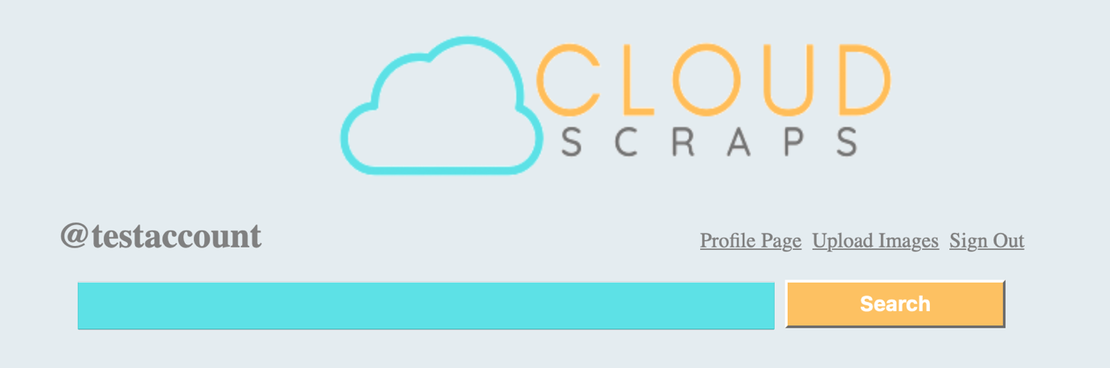

Figure - Home Page

You can now continue to click the Upload Images link at the upper righthand corner where you will be greeted with a new pane that asks for all required fields to be filled in before uploading the image you have chosen.

Figure - Uploading an Image

Once your upload has completed successfully you are redirected to the home page where your uploaded image now sits in the cloud waiting for you to view, edit, download or delete it.

Figure - Example of Uploaded Images

As you can see in the figure above, all images wrap dynamically to fill your screen.

This now brings us to the final page on our website, here you can edit your albums, and manipulate them as you need. This Profile Page only includes the images that you have uploaded and not the ones that have been shared with you as well like on the Home Page.

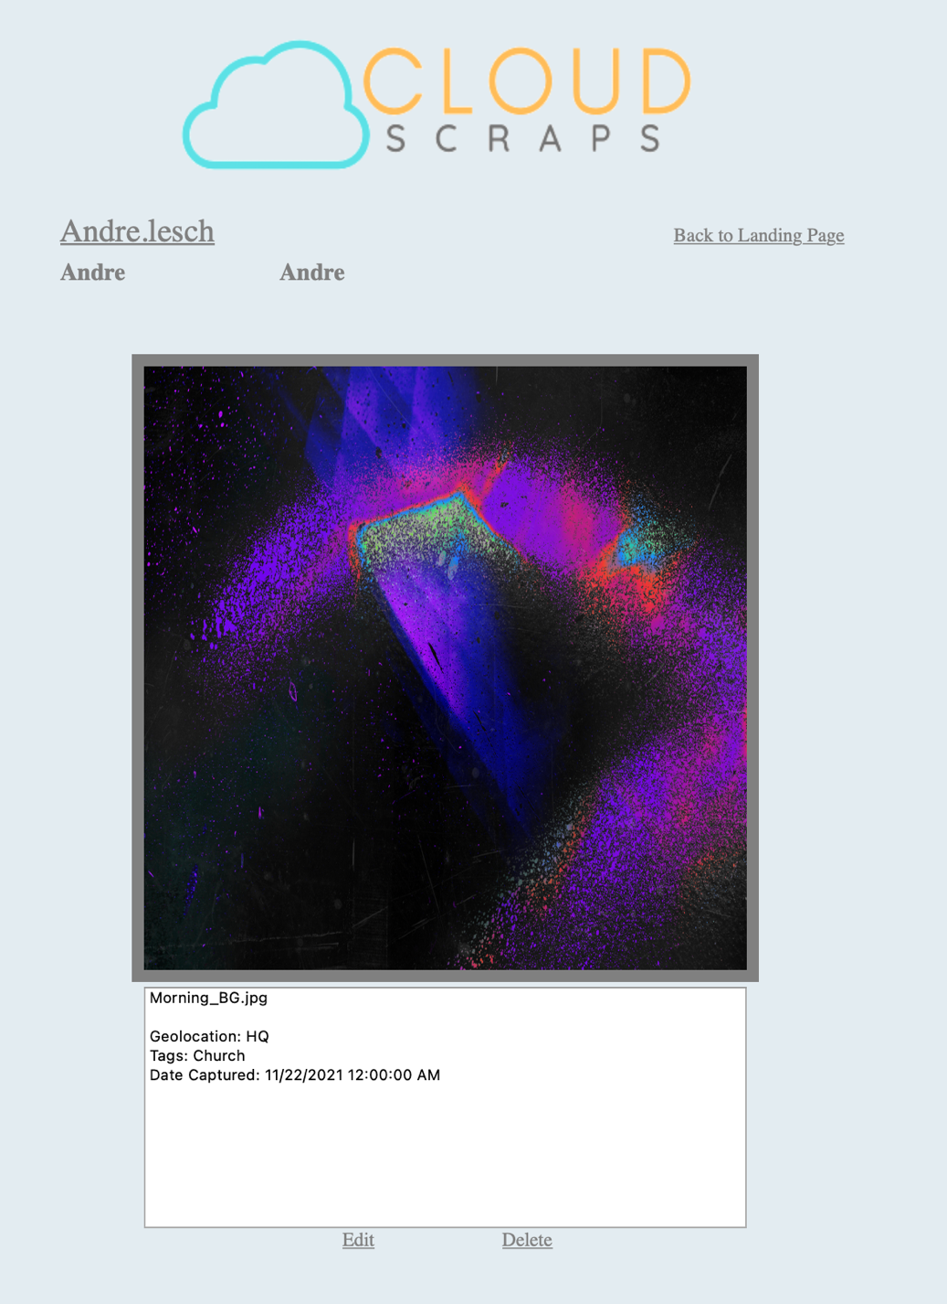

**Lesch**

Figure - Profile Page

From the Profile page in the figure above, you can click on your own privately uploaded images and be greeted by what is seen above, a larger view of the selected image with its metadata and buttons to both edit and delete the photo. You can also edit your albums etc straight from the Profile Page.

# Conclusion

Too conclude, the past few weeks were both the best and worst days of our lives. There were sleepless nights were we struggled to figure out one error, and other days where everything worked so flawlessly in harmony that for a while we forgot about the bad parts.

This is our project, CloudScraps, your online cloud based scrap booking platform. A platform where you can create, edit, share and store your images online in a safe to use environment, one that puts the user and his or her needs as first priority.